**M2C Final Project Plan**

**Helen Kim**

**Part 1: Overview**

For my final project, I will be creating a web app that allows users to create a list of restaurants they want to go to and allow them to customize the lists with unique titles and each added restaurant will also have tags that allow the user to search through the personal lists. The web app will heavily rely on the Yelp Search API to provide the necessary information (name of establishment, image, location, etc). I predict that authentication will not be necessary since users will not be saving Yelp account sensitive information.

**Part 2: Storyboard (Desktop & Mobile)**

Desktop Version:

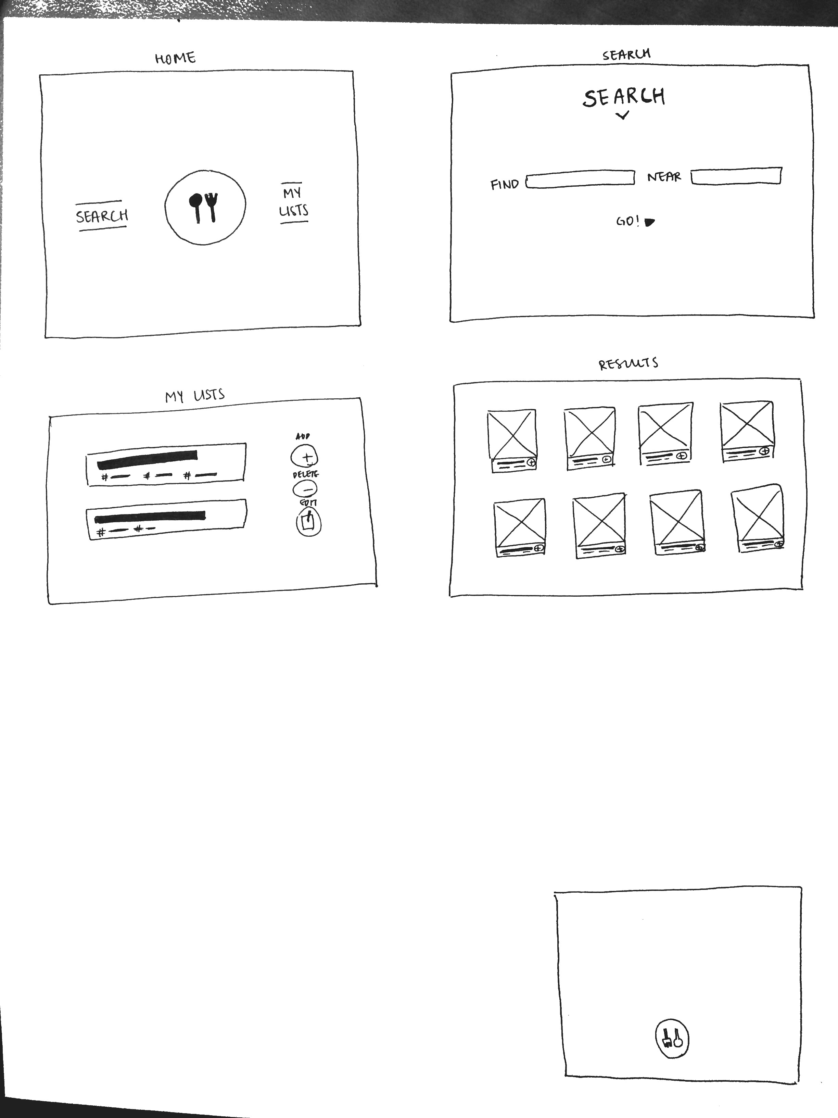

Mobile Version:

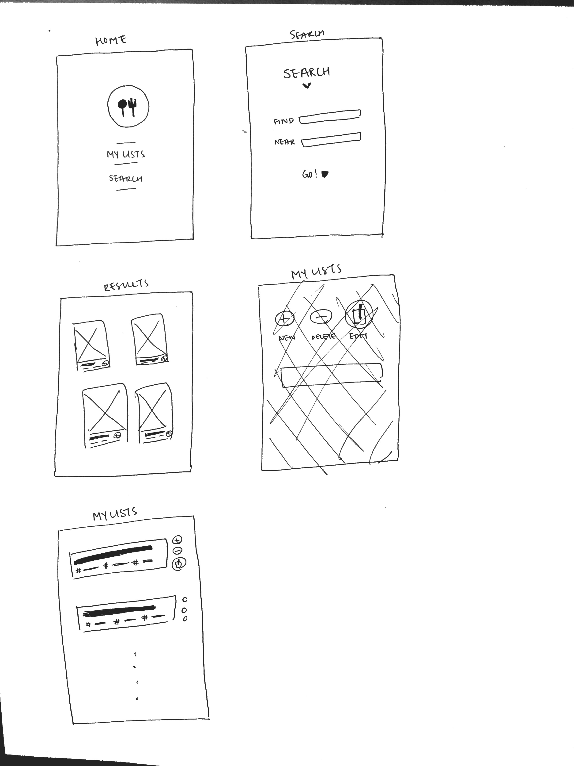



**Part 3: API & API methods**

Two restaurant APIs are available for use with extensive documentation:

* Yelp Search API (<https://www.yelp.co.uk/developers/documentation/v2/overview>)
* Zomato API (<https://developers.zomato.com/documentation>)

Either one may be used but most likely Yelp since its search parameters is more extensive.

Since the web app is mainly focused on searching for restaurants, it will only be using GET methods from the API, using search queries to populate results and lists.

**Part 4: Controller & Routes**

1. get(/search/:term/:location) – to find restaurants using any keyword (e.g. “dinner”, “Italian”) and search location.
2. get(/mylist/:title?) – return a specific list by title or return all my lists if unspecified.
3. post|put|delete(/mylist/:title) – update|create|destroy list by title

**Part 5: Model & Business Logic**

1. getRestaurants() – find restaurants based on search query from API
2. createRestaurant() – using information found, allow user to create the restaurant card with custom tags
3. putList(), postList(), deleteList() – create, update, delete restaurant list
4. filter() – using tags, filter restaurants in my list

**Part 6: Stored Data**

The user’s lists will be saved for future reference. To reduce the load of saved data, it will probably be saved in a json containing just the unique restaurant ids and filters for the lists to use when recreating the lists during a returning user’s session or during offline use.